**1.Animal**

dog(fido).

dog(rover).

dog(henry).

cat(felix).

cat(jane).

animal(X):-dog(X).

**Answer Quueries:**

1. **Find the names of the Dog**

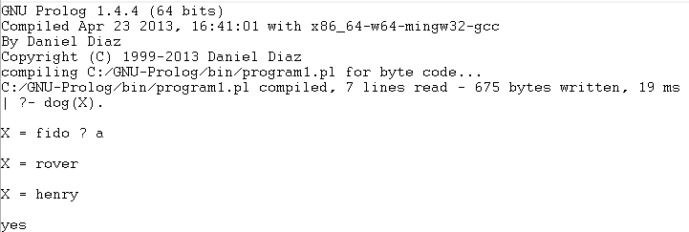

1. **Find the names of cat**

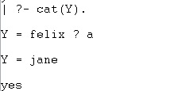

1. **Anything is an animal if it is a Dog**

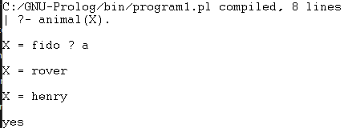

**2.Large Animal**

dog(fido).

dog(rover).

dog(tom).

cat(mary).

cat(bill).

large(fido).

large(rover).

large(bill).

large_animal(X):-dog(X),large(X).

**Answer Query**

1. **Who is a large animal**

**3.Family Tree**

parent(charlie,james).

parent(elizabeth,james).

parent(george,sophia).

parent(catherine,sophia).

parent(charlie,kith).

**Answer Querie:**

1. **Was George parent of Sophia**



1. Who are James Parents?

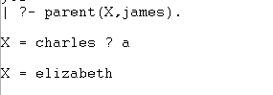

1. **Who are the children of charlie?**

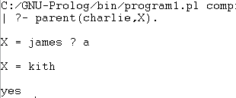

1. **Who is the parent of whom?**

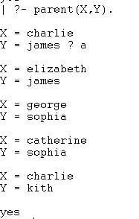**4.Like logic**

likes(john,susie).

likes(X,susie).

likes(john,X).

likes(X,john).

likes(john,mary).

likes(john,susie):-likes(john,mary).

not(likes(john,pizza)).

**Answer queries**

i)  **Does John likes Susie?**

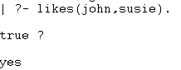

**ii) Whom does John likes?**

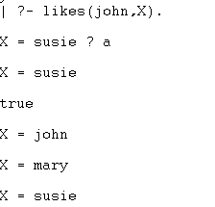**5.Random Facts**

cat(tom).

lovestoeat(kunal,pasta).

lovestoplay(nawaz,games).

black(hair).

lazy(pratyusha).

happy(lili).

hungry(tom).

friends(jack,bill).

play(ryan).

dances(lili):-happy(lili).

searching(tom,food):-hungry(tom).

loves(jack,cricket),loves(bill,cricket):-friends(jack,bill).

school(closed),free(ryan):-play(ryan).

**Answer queries**

**i) Who loves to eat pasta?**

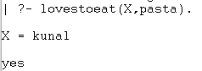

**ii) Who is lazy?**

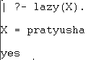

**iii) Who loves to play game?**



**iv) Is Lili happy?**



**v) Will Ryan go to play?**

**6.Parent of who**

parent(pam,bob).

parent(tom,bob).

parent(tom,liz).

parent(bob,ana).

parent(bob,pat).

parent(pat,jim).

grandparent(X, Z) :- parent(X, Y), parent(Y, Z).

**Answer queries:**

**1) Who is a grandparent of Jim? (Hint: break down the query into 2 predicates)**

|  |  |
| --- | --- |
|  | **or** |

**2) Who are Tom's grandchildren?**

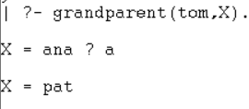

**3) Do Ann and Pat have a common parent?**

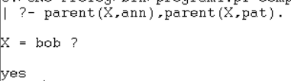

**4) Who is Pat's parent?**

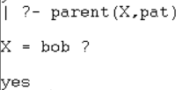

**5) Who is Pat's grandparent?**

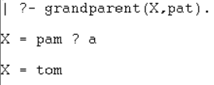

**6) Does Liz have a child?**



**7.Traveler**

woman(jia).

man(john).

healthy(john).

healthy(jia).

wealthy(john).

traveler(X):-healthy(X),wealthy(X).

can_travel(X):-traveler(X).

**Answer queries.  
 (1) Who can travel?**

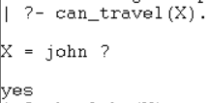  
 **(2) Who is healthy and wealthy?**

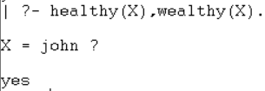**8.Food and Meals**

food(burger).

food(sandwhich).

food(pizza).

lunch(sandwhich).

dinner(pizza).

meal(X):-food(X).

**Answer queries:**

|  |  |
| --- | --- |
| **1. Is pizza a food?**  **2.** **Which food is meal and lunch?**  **3.** **Is sandwich a dinner?** |  |

**9.Students and Professors**

studies(charlie,csc135).

studies(olivia,csc135).

studies(jack,csc131).

studies(arthur,csc134).

teaches(kirke,csc135).

teaches(collins,csc131).

teaches(collins,csc171).

teaches(juniper,csc134).

professor(X,Y):-teaches(X,C),studies(Y,C).

**Answer queries:**

|  |  |
| --- | --- |
| **1.** **What does charlie study?**  **2.** **Who are the students of professor kirke.** |  |

**10. Sick Patients**

suffering(charlie,fever).

suffering(charlie,runny_nose).

suffering(charlie,headache).

suffering(micky,cough).

suffering(micky,headache).

suffering(micky,runny_nose).

suffering(micky,sneezing).

suffering(branda,fever).

suffering(branda,rash).

has(P,flu):-suffering(P,headache),suffering(P,bodyache),suffering(P,fever),suffering(P,runny_nose),suffering(P,cough),suffering(P,conjunctives).

has(P,measles):-suffering(P,fever),suffering(P,cough),suffering(P,conjunctives),suffering(P,runny_nose),suffering(P,rash).

has(P,whooping_cough):-suffering(P,cough),suffering(P,sneezing),suffering(runny_nose).

**Answer queries**

**a)** **Who is suffering from fever?**

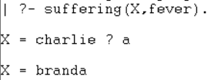

**b)** **Which symptoms Branda is suffering from?**

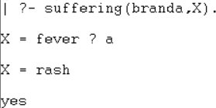

**c)** **Find the common patients with symptoms headache and running nose.**

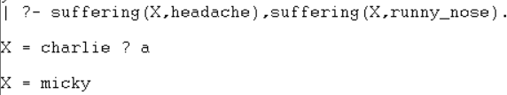

**d)** **Find the common symptom of Charlie and Micky.**

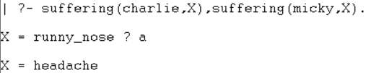

**11.The return of Markus!**

man(marcus).

pompeian(marcus).

ruler(caesar).

trytoassassinate(marcus, caesar).

loyal(X, Y) :- not(trytoassassinate(X, Y)).

hate(X, Y) :- trytoassassinate(X, Y).

roman(X) :- loyal(X, caesar); hate(X, caesar).

pompeian(X) :- roman(X).

people(X) :- man(X).

**Answer queries:**

|  |  |
| --- | --- |
| **i)** **Who tried to assassinate ruler?**  **ii)** **Was Marcus loyal to Caesar?**  **iii)** **Whom did Marcus hate?** |  |

**12. Bro got immune system of medieval age**

symptom(moderate_cough,flue).

symptom(chills,flue).

symptom(severe_body_ache,flue).

symptom(running_nose,flue).

symptom(chills,chickenpox).

symptom(high_fever,chickenpox).

symptom(mild_body_ache,cold).

symptom(running_nose,cold).

symptom(chills,cold).

**Answer Queries:**

**i)** **Get the list of all the diseases for which running nose is a symptom.**

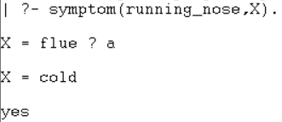

**ii)** **Find all the symptoms for disease cold.**

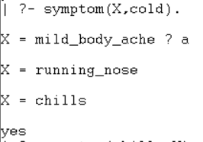

**iii)** **Find out if there are any diseases with symptom chills.**

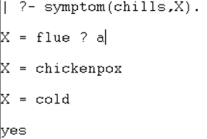

**iv)** **Find out all the possible diseases with symptom mild body ache or runny nose.**

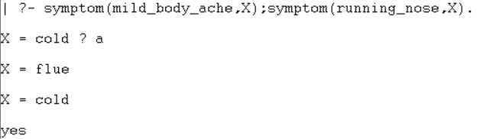

**v)** **Which are the common symptoms for cold and flu.**

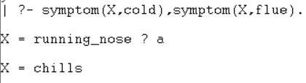

**13.Who is who**

father(john,alice).

mother(alice,tom).

sister(mary,alice).

son(tom,alice).

brother(paul,mary).

husband(john,sarah).

wife(sarah,john).

**Answer Queries:**

|  |  |
| --- | --- |
| 1. **Is John the father of Alice?** 2. **Who is the mother of Tom?** 3. **Is Mary the sister of Alice?** 4. **Who is the husband of Sarah?** 5. **Who is the wife of John?** |  |

**14. Around the world**

capital(paris,france).

capital(london,england).

capital(berlin,germany).

capital(rome,italy).

capital(madrid,spain).

capital(tokyo,japan).

capital(delhi,india).

**Answer Queries:**

|  |  |
| --- | --- |
| 1. **Is Paris the capital of France?** 2. **What is the capital of Japan?** 3. **Is Berlin the capital of Germany?** 4. **What is the capital of Italy?** 5. **Is Madrid the capital of Portugal?** |  |

**15. Tools**

furniture(chair).

furniture(table).

furniture(bed).

utensil(spoon).

utensil(fork).

utensil(knife).

electronic_device(laptop).

category(X,furniture):-furniture(X).

category(X,utensil):-utensil(X).

category(X,electronic_device):-electronic_device(X).

**Answer Queries:**

|  |  |
| --- | --- |
| 1. **Is a chair considered furniture?** 2. **What category does a spoon belong to?** 3. **Is a laptop an electronic device?** 4. **What category does a knife belong to?** 5. **Is a bed a utensil?** |  |

**16. Still searching for my family.**

father(david,emma).

mother(emma,liam).

brother(liam,olivia).

daughter(olivia,emma).

grandmother(sophia,liam).

grandfather(michael,liam).

husband(david,emmas_mother).

**Answer Queries:**

|  |  |
| --- | --- |
| 1. **Who is the grandmother of Liam?** 2. **Is Olivia the daughter of Emma?** 3. **Who is the grandfather of Liam?** 4. **Is David the father of Liam?** 5. **Who is the husband of Emma’s mother?** |  |

**17. Careers**

treats(doctor,patients).

educates(teacher,students).

designs(engineer,solutions).

grows(farmer,crops).

flies(pilot,airplanes).

prepares(chef,food).

creates(writer,stories).

**Answer Queries:**

|  |  |
| --- | --- |
| 1. **Who treats patients?** 2. **Does a farmer prepare food?** 3. **Who grows crops?** 4. **What does an engineer design?** 5. **Does a pilot fly airplanes?** |  |